Laboratory 3 – Bipolar Junction Transistor (BJT) and Amplifier

Ratthamnoon Prakitpong (63205165)

L2B

03/22/2019

Hassan Iqbal & Steven McCullough

Task 1:

We assemble a circuit according to Figure 1, using parameters found in Table 1.1. These parameters are based on pre-lab calculations (refer to pre-lab attached), with the values being the closest real world equivalent of the theoretical parameters.

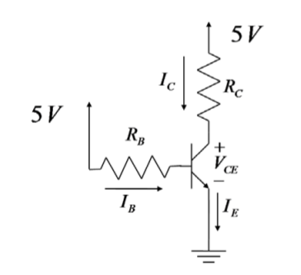

Figure 1: Task 1 Circuit

|  |  |  |
| --- | --- | --- |
| Rb | 43.5400 | k-ohms |
| Rc | 0.1975 | k-ohms |

Table 1.1: Task 1 Parameters

|  |  |  |
| --- | --- | --- |
| Ic | 9.1669 | mA |
| Ib | 0.0983 | mA |
| beta | 93.2319 |  |

Table 1.2: Task 1 Relevant Measurements and Calculation

We have obtained beta by:

beta = Ic/Ib

Equation 1: Task 1 Calculation

To find the accuracy of our experiment:

% Accuracy = (theoretical - real)/theoretical = (100 - 93.2319)/100 = 6.8%

Calculation 1: Task 1 Verification Calculation

The obtained value is within +/-10% of the theoretical beta value of 100. The result here is very accurate.

Task 2:

We assemble a circuit according to Figure 2, using parameters found in Table 2.1. These parameters are based on pre-lab calculations (refer to pre-lab attached), with the values being the closest real world equivalent of the theoretical parameters.

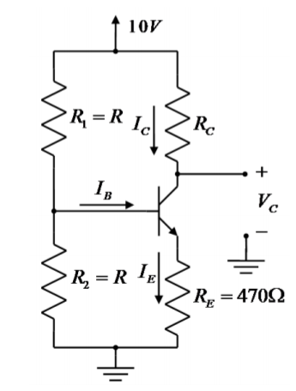

Figure 2: Task 2 Circuit

|  |  |  |
| --- | --- | --- |
| R1 | 119.5000 | k-ohms |
| R2 | 118.0000 | k-ohms |
| Rc | 0.9850 | k-ohms |
| Re | 0.4620 | k-ohms |

Table 2.1: Task 2 Parameters

|  |  |  |
| --- | --- | --- |
| VR1 | 6.8960 | V |
| VR2 | 3.1549 | V |
| VRc | 5.1830 | V |
| VRe | 2.4444 | V |
| VC | 4.8560 | V |

Table 2.2: Task 2 Measurements

We take measurements across resistors and Vc, and use them to for our calculations:

Ib = VR1/R1 - VR2/R2

Ic = VRc/Rc

Ie = VRe/Re

Ve = VRe

Vc = VC

Equations 2: Task 2 Calculations

We can obtain the following values:

|  |  |  |
| --- | --- | --- |
| Ib | 0.0310 | mA |
| Ic | 5.2619 | mA |
| Ie | 5.2909 | mA |
| Ve | 2.4444 | V |
| Vc | 4.8560 | V |

Table 2.3: Task 2 Calculations

We can verify that these values are accurate by seeing that we can relate our calculated values and see that they are accurate within +/- 10%:

Ie = Ic + Ib

5.2909 mA ≃ 0.0310 mA + 5.2619 mA = 5.2929 mA

% Accuracy = (theoretical - real)/theoretical = (5.2929 - 5.2909)/5.2929 = 0.038%

Calculation 2.1: Task 2 First Verification Calculation

Ic = (Vcc - Vc)/Rc

5.2619 mA ≃ (10 V - 4.8560 V)/985 ohms = 5.2223 mA

% Accuracy = (theoretical - real)/theoretical = (5.2223 - 5.2619)/5.2223 = 0.076%

Calculation 2.2: Task 2 Second Verification Calculation

Task 3:

We assemble a circuit according to Figure 3, using parameters found in Table 3.1. These parameters are based on pre-lab calculations (refer to pre-lab attached), with the values being the closest real world equivalent of the theoretical parameters.

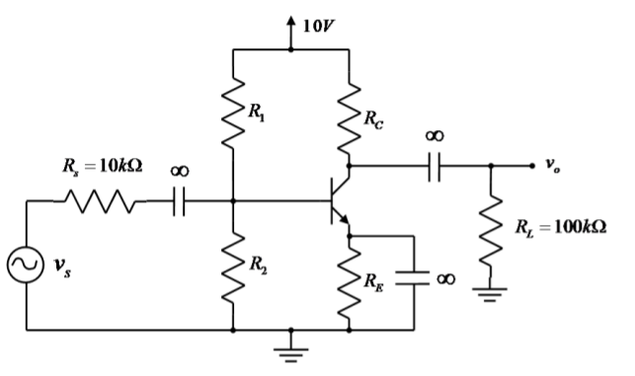

Figure 3.1: Task 2 Circuit

|  |  |  |
| --- | --- | --- |
| Rs | 9.837 | k-ohms |
| Rl | 98.5 | k-ohms |
| R1 | 119.5 | k-ohms |
| R2 | 118.9 | k-ohms |
| Rc | 0.983 | k-ohms |
| Re | 0.462 | k-ohms |

Table 3.1: Task 3 Resistance Parameters

For capacitors, we have to choose them so that they are sufficiently small for the frequency used in the lab (1 kHz). The TA chose a factor of 100 as a sufficient value to determine the capacitance as small:

R >> 1/jwC

R ≃ 100/jwC

C ≃ 100/jwR

Equation 3.1: Capacitor Selection Equation

C3 = 100/jwRe

C3 = 100/(1000 Hz)2pi(470 ohm)

C3 = 33.86 uF

Calculation 3.1: Capacitor Selection Sample Calculation

The capacitances at Table 3.2 were calculated and chosen as shown below, where C1 corresponds to capacitor in series with Rs, C2 to capacitor in series with Rl, and C3 to capacitor parallel to Re. The numbers in the table are the closest real capacitor values closest to theoretical calculation, chosen by the lab TA.

|  |  |  |
| --- | --- | --- |
| C1 | 1.5 | uF |
| C2 | 1.5 | uF |
| C3 | 10 | uF |

Table 3.2: Task 3 Capacitance Parameters

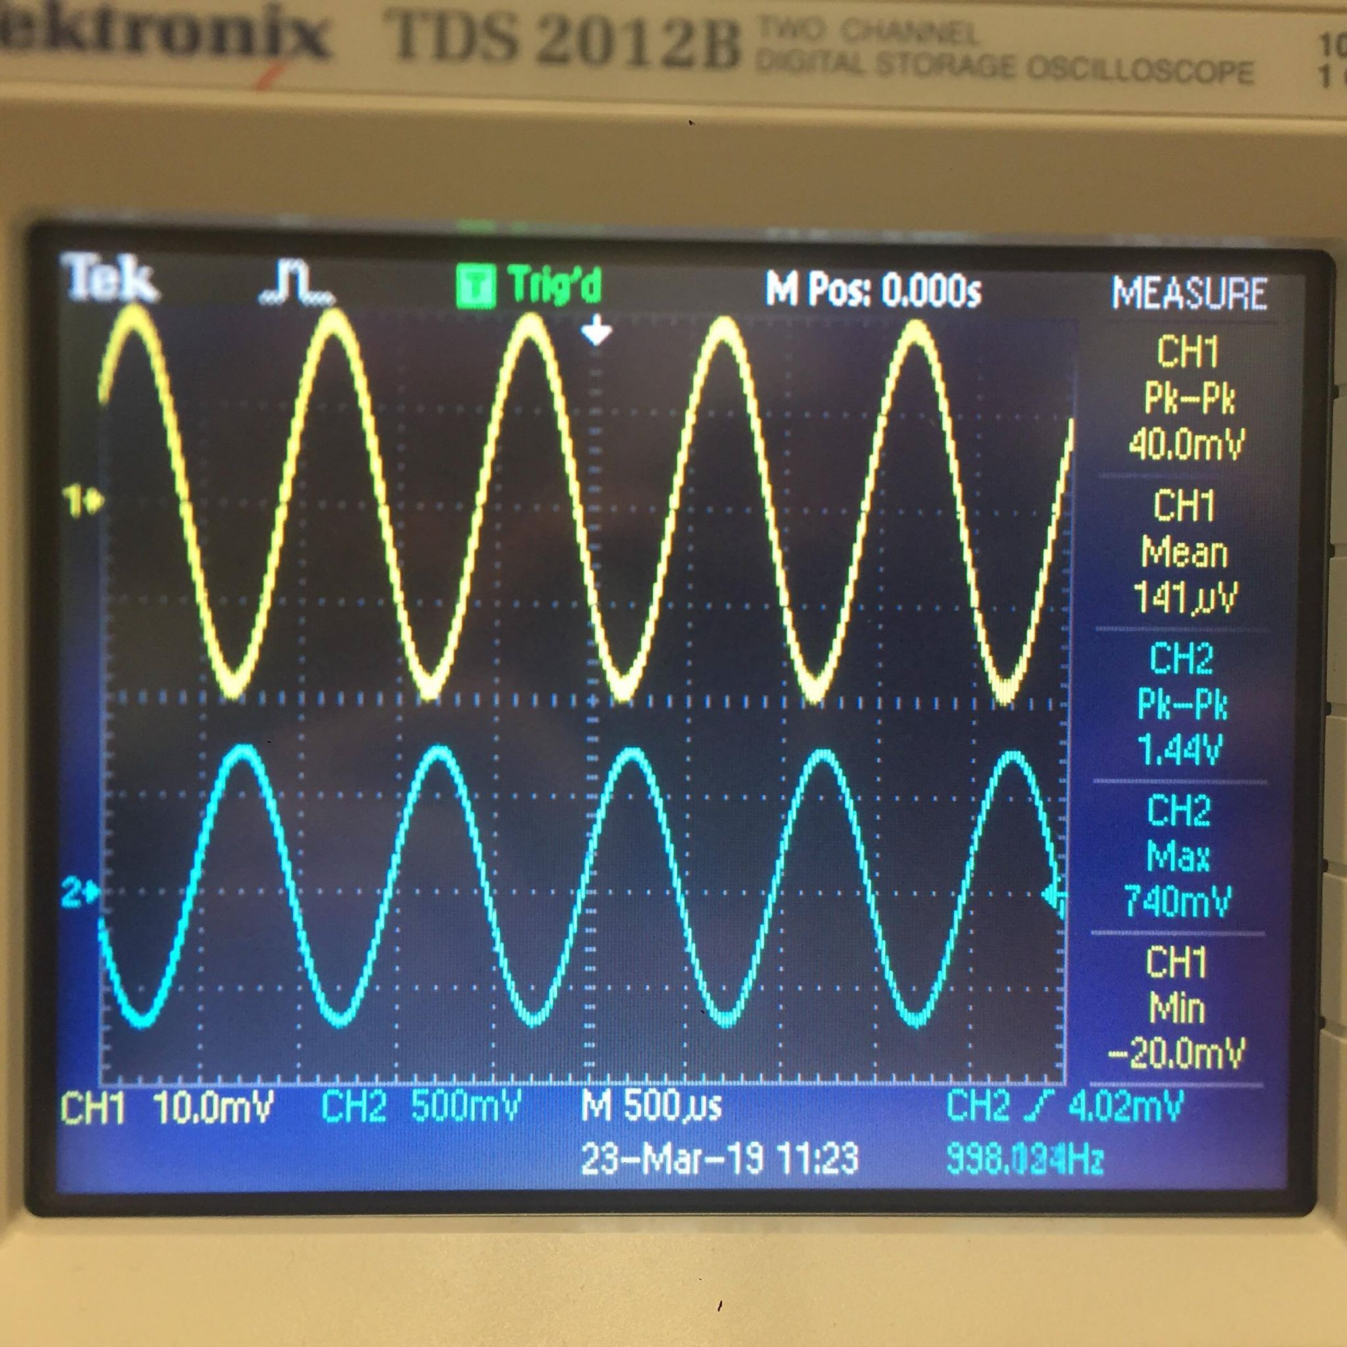

Figure 3.2: Vs (top) vs Vo (bottom) at Vcc = 10V

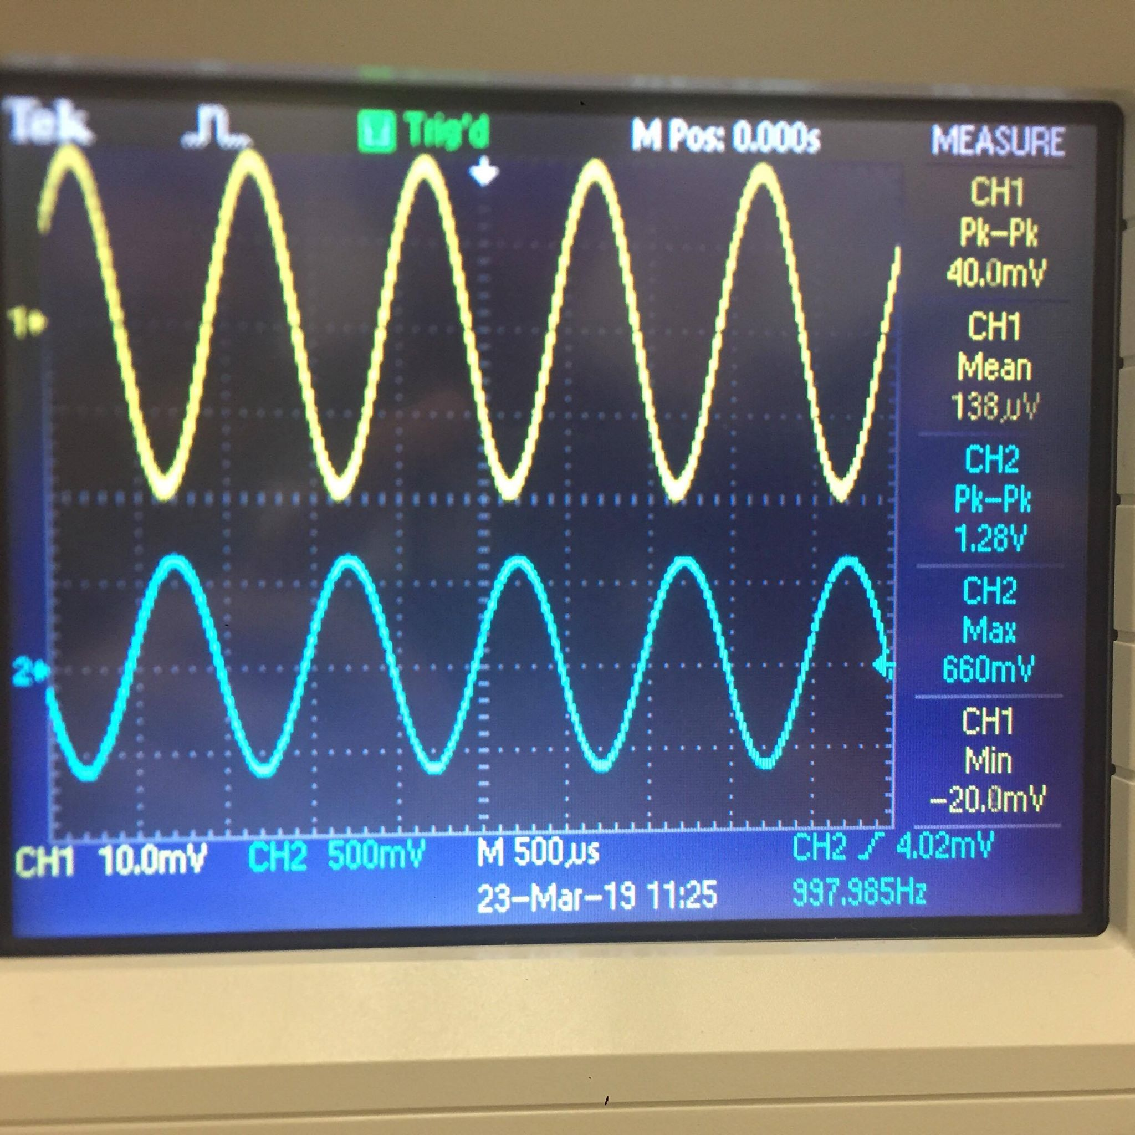

Figure 3.3: Vs (top) vs Vo (bottom) at Vcc = 4V

Extracting values from the Vs vs Vo plots:

|  |  |  |
| --- | --- | --- |
| Vs, DC=10V | 0.04 | V |
| Vo, DC=10V | 1.44 | V |
| Vs, DC=4V | 0.04 | V |
| Vo, DC=4V | 1.28 | V |

Table 3.3: Task 3 Measurements

To get Av, we use the equation:

Av = -Vo/Vs

Equation 3.2: Av Equation

Our measurements when calculated produce these values:

|  |  |
| --- | --- |
| Av, DC=10V | -36 |
| Av, DC=4V | -32 |

Table 3.4: Task 4 Calculations Based on Measurements

It makes sense that at higher DC input, Av is higher. Extending from the pre-lab:

Vo = -(RLRC/(RC+RL))(gmVpi)

Vo = (RLRC/(RC+RL))gm(Vs(R2R1rpi/(R2R1+R1rpi+R2rpi))

Vo = (RLRC/(RC+RL))gm(Vs(R2R1(beta/gm)/(R2R1+R1(beta/gm)+R2(beta/gm)))

Vo = ((RLRC/(RC+RL))(Vs(R2R1beta)))(1/(R2R1+R1(beta/gm)+R2(beta/gm)))

Vo ∝ (1/(R2R1+R1(beta/gm)+R2(beta/gm)))

Where R2, R1, beta are constants, gm = Ic/Vt, Ic = (V(DC)-Vc)/Rc, and Vc, Rc can be considered constant

Vo ∝ 1/((R1+R2)beta/((V(DC)-Vc)/RcVt))

Vo ∝ 1/(beta/V(DC))

Vo ∝ V(DC)

Calculation 3.1: Vo Correlation to V(DC) Calculation

We can see Vo and DC input voltage are linearly proportional. Our values where Av of a larger DC input (Av = -36) is larger than Av of a smaller DC input (Av = -32) supports our calculation.

The theoretical value of Av for V(DC) = 10V based on our calculated beta value of 93.2319 (Table 1.2) can be found in this calculation:

Av = Vo/Vs

Where Vo = -gm(RLRC/(RC+RL))(Rin/(Rs+Rin))Vs, Rin = (1/R1+1/R2+gm/beta)^-1, gm = Ic/Vt

gm = 5.2223 mA/25 mV = 0.2089 A/V

Rin = (1/119500+1/118900+0.2089/93.2319)^-1 = 443.0 ohms

Vo = -0.2089(98500*983/(98500+983))(443.0/(9837+443.0))Vs = -8.76Vs

Av = -8.76

Calculation 3.2: Theoretical Av of V(DC) = 10V

While both amplifying factor shows output voltage being inverted, the value does not match up at all to measured values from Table 3.4. This is unlikely to be caused by hardware failure, since all the other measured values match up with theoretical values. Additionally, theoretical value is unlikely to be incorrect, since it matches closely with the prelab value of -9.3. We predict that we have connected the Vo multimeter probe to the incorrect wire. Further analysis outside the scope of this lab will have to be performed to see which voltage most closely matches the measurement values from Table 3.4.